ST MICHAEL AND ALL ANGELS CHURCH BEDFORD PARK

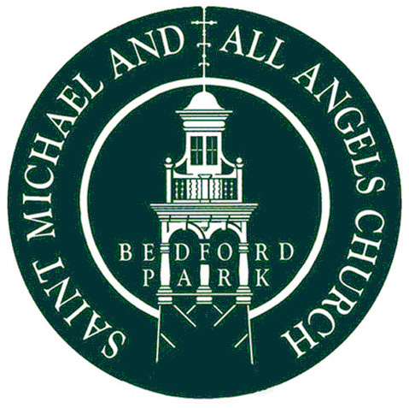

Parishioners Meeting
and
Annual Parochial Church Meeting
To be held in the Church Hall on Sunday 28th April 2024 at 11.30am

Agenda

- Parish Meeting

- Election of Churchwardens: Christina Whiteway and Peter Haigh.

- Annual Parochial Church Meeting

- Notice of Meeting:

- Apologies for Absence.

- Minutes of the 2023 APCM

- Matters Arising from the Minutes.

- Election of Lay Members to the PCC: Helen Simkin

- To Receive the Annual Report and Accounts for 2023.

- Financial Overview for 2023

- Re-appointment of the Independent Examiner.

- Report on the Electoral Roll.

- Fabric Report.

- Report on progress with the Memorial Garden.

12. St Michael’s in 2023: slideshow.

13. Any Other Business: to be submitted to the secretary (via the parish office) by 24th April 2024.
The Annual Report and Accounts will be available from the SMAAA website a week before the APCM and a hard copy will also be placed on the noticeboard in the church porch. A few hard copies will be available at the meeting. Please help us save paper by bringing your copy on your IPad or other device. Please contact the PCC secretary if you cannot access the reports by these routes.

