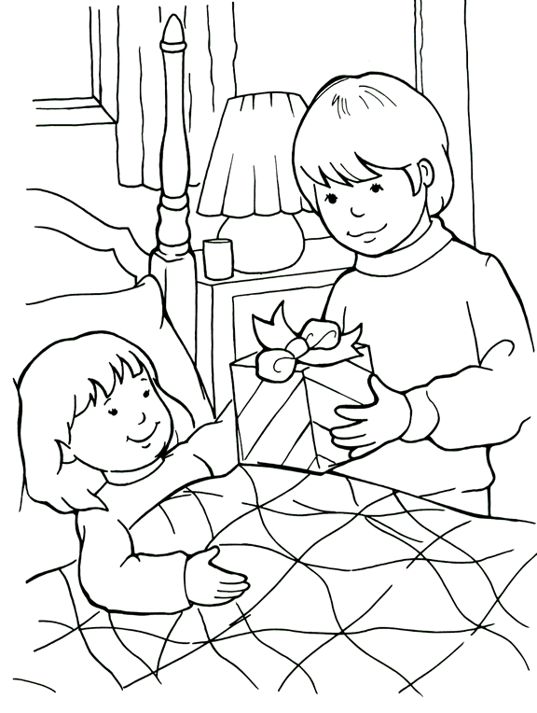
BE A FRIEND TO THE SICK COLOURING PAGE
I can be a friend to someone who is sick.

