The Triumphal Entry Colouring Page
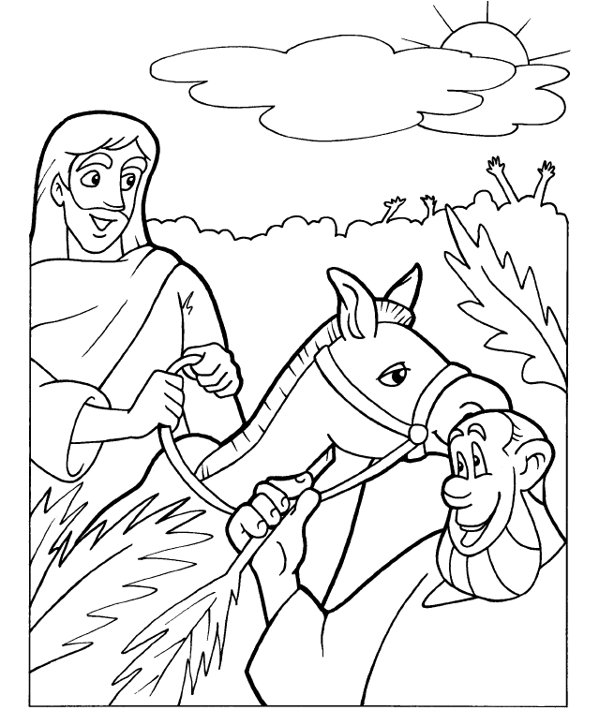
The Triumphal Entry

