The Shepherd
Dot to Dot
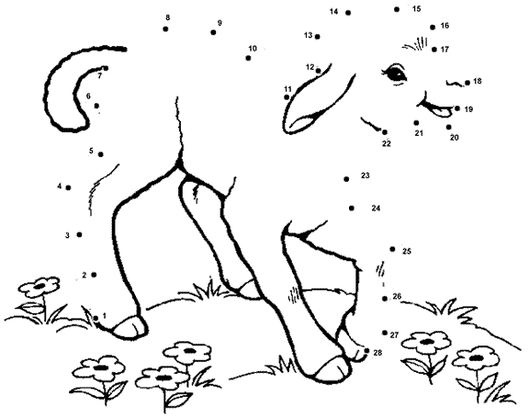
Connect the dots to complete the picture.
When he has brought out all his own, he goes on ahead of them, and his sheep follow him because they know his voice.
John 10:4

