The Shepherd
Colouring Page
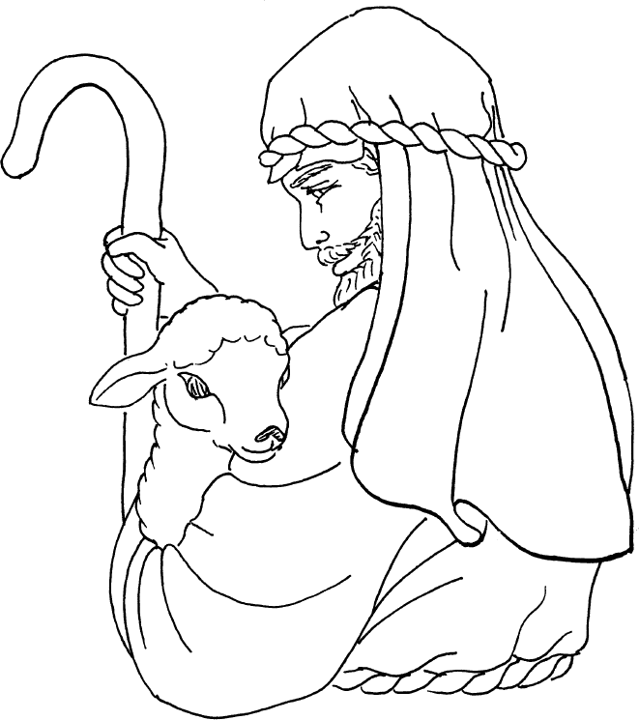
The sheep follow him because they know his voice.

