Jesus Raises Lazarus from the dead Word Jumble

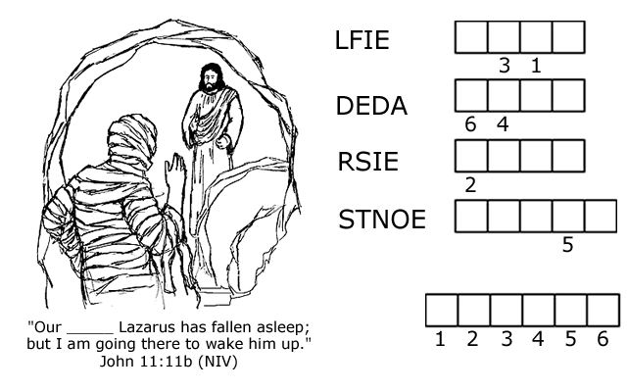
Unscramble each word, then arrange the circled letters to form a word that will complete the statement that Jesus made about himself.
HERE ARE SOME CLUES IN CASE YOU NEED HELP!
- Jesus said to Martha, "I am the resurrection and the ______. John 11:25 (NIV)
- The opposite of alive.
- Jesus said to her, "Your brother will ______ again." John 11:23 (NIV)
- The entrance to the tomb was covered by a _________. John 11:38 (NIV)

