Jesus Raises Lazarus from the Dead
Maze
Jesus Raises Lazarus
John 11
Help Lazarus find the way to Jesus.
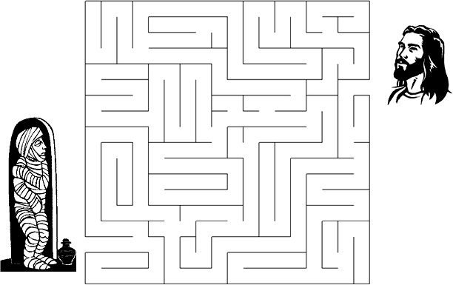
Then Jesus shouted, "Lazarus, come out!" And Lazarus came out,
bound in graveclothes, his face wrapped in a headcloth.
John 11:43-44a (NLT)

