I AM THE WAY POSTER

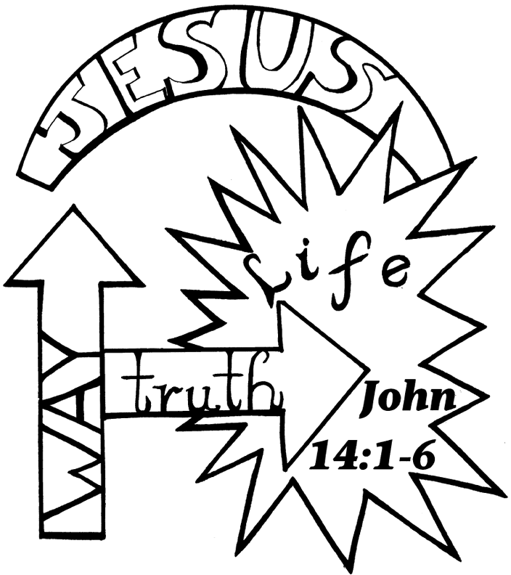
Copyright © CalvaryCurriculum.com
Used by permission

