I Am the Way
Dot to Dot
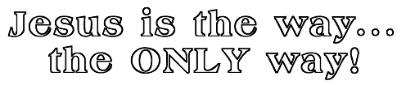
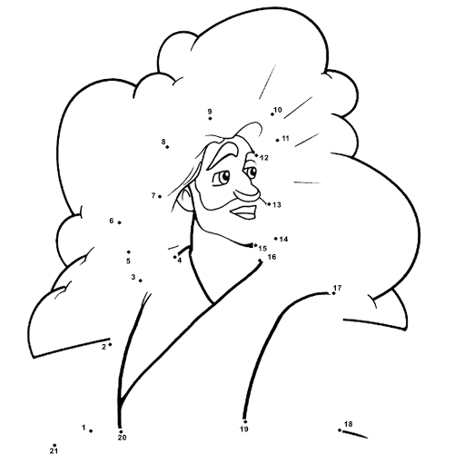
Jesus answered, "I am the way, the truth, and the life.
No one comes to the Father except through me.
John 14:6 (NIV)

