God So Loved the World
Colouring Page
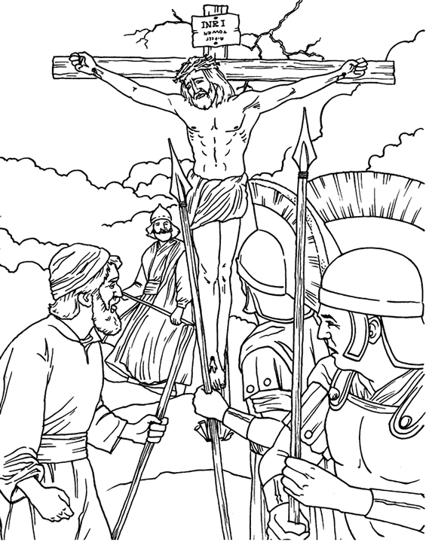
For God so loved the world, that he gave his only begotten Son, that
whosoever believeth in him should not perish, but have everlasting life.
John 3:16

