Finding The Way
Maze
FINDING THE WAY THROUGH THE MAZE
"I am the way, the truth, and the life."
John 14:6
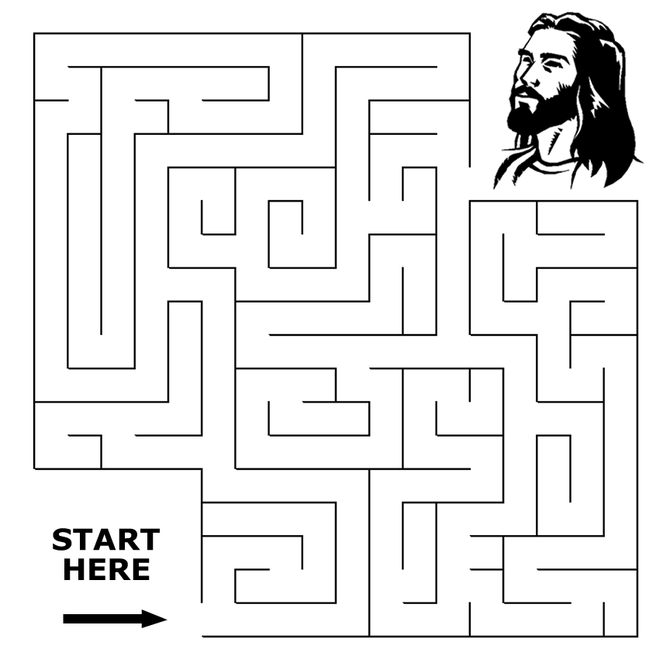
Can you find the way to Jesus?
Copyright © Sermons 4 Kids, Inc.
All rights reserved.
Sermons4Kids.com

