Resurrection
Colouring Page
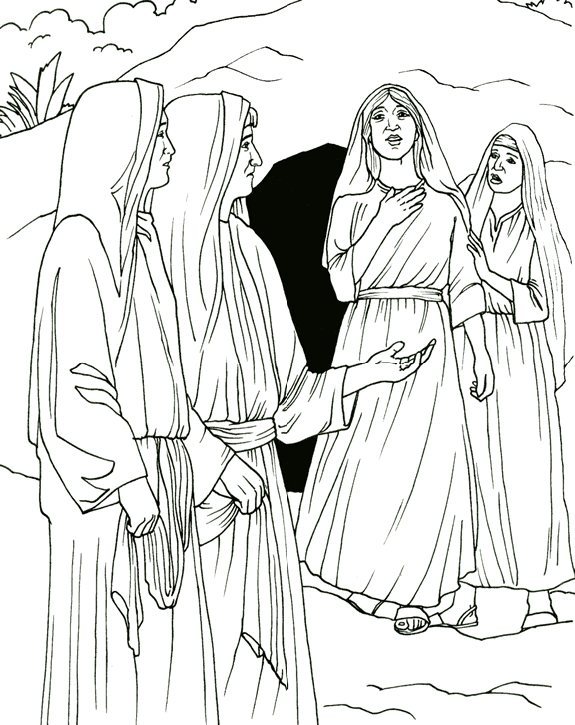
Resurrection

