Doubting Thomas
Coloring Page
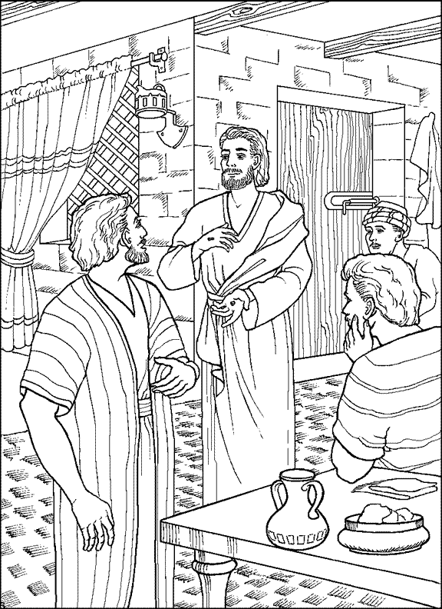
Jesus Appears to Thomas

