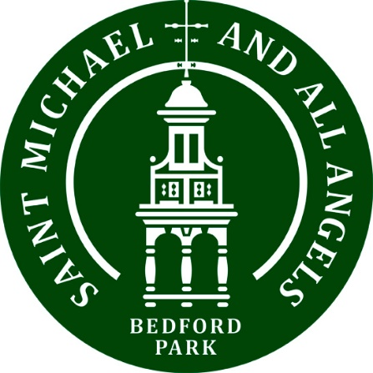

Could you offer some time or practical help?

West London Welcome is our new St Michael’s charity. Based at the Quaker Meeting House in Hammersmith, it is a free drop-in centre for refugees, asylum seekers, and migrants who have settled in West London and the wider London area, providing them with the access to the services and support they need to lead full lives within their local community. Those of us who have already spent time there have been struck by the warm, welcoming atmosphere… and the very tasty lunch!

As Fr Kevin said when he announced our new charity, we are keen not just to offer financial support but get involved as a church community. If you feel you might be able to offer a few hours of your time in any of the areas mentioned overleaf (or if you just want some more information), please have a word with Cathy Millin, Paula Nelson or John Clark or email johnclark@gmx.co.uk .

Maybe you could team up with friends at church to get involved.

Have a look at their website to get a feel for what they are doing: https://westlondonwelcome.com

Volunteering Opportunities at West London Welcome

Knitting Group
We are looking for one or more people who can run a knitting class on Thursday am/pm

Outings/events and evenings
We would love to hear from anyone willing to organise an outing or event for our clients. This could be a trip to a museum or garden, or hosting an evening at our centre – perhaps a film-night, talk or dance.

Runners
We buy places on the Fulham 10k and are always looking for people willing to do the run and collect sponsorship through our Localgiving crowdfunding platform.

Musicians, dancers, drummers, singers
We are interested in hearing from teachers. It would be fun to hold a family ceilidh, for example.

Donation Coordinator
We are looking for someone with a car who is willing to organise the donated clothing and furniture for collection and distribution. They will need to assist our service users to get essential items they can’t afford to buy. The coordinator can organise their own timetable, but visiting the centre fortnightly/monthly on Thursdays for a couple hours is important. It’s a good opportunity to help directly with real needs and get to know our clients.

HR Expert
We are looking for someone with HR experience and expertise.

--------------------------

HOUSING

Can you offer a spare room to a refugee?
One of the biggest challenges for our clients is finding somewhere to live in London. We have asylum seekers who are street homeless or sofa surfing and we refer them to two hosting charities, Refugees At Home and Room For Refugees, but very often these charities have a long waiting list so we would encourage anyone with a spare room to sign up as a host. We are very happy to chat with anyone interested about how the schemes work.

We would also love to hear from landlords with either a spare room, a flat or house to rent who would be willing to rent at Local Housing Authority rates. We currently desperately need an affordable 3 bedroom home for a Syrian family.

