Ascension
Maze
The Ascension of Jesus
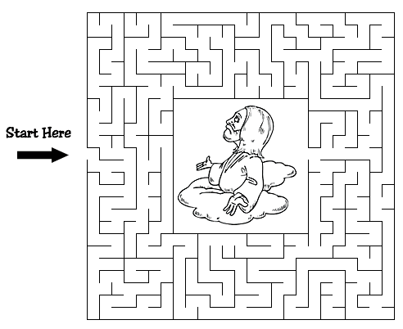
After he said this, he was taken up before their very eyes,
and a cloud hid him from their sight.
Acts 1:9 (NIV)

